**Bill of Materials – Cocoon Express**

* Motors
  + [Hobby Motor with Encoder - Metal Gear (DG01D-E)](https://www.sparkfun.com/hobby-motor-with-encoder-metal-gear-dg01d-e.html)
  + Sparkfun
  + 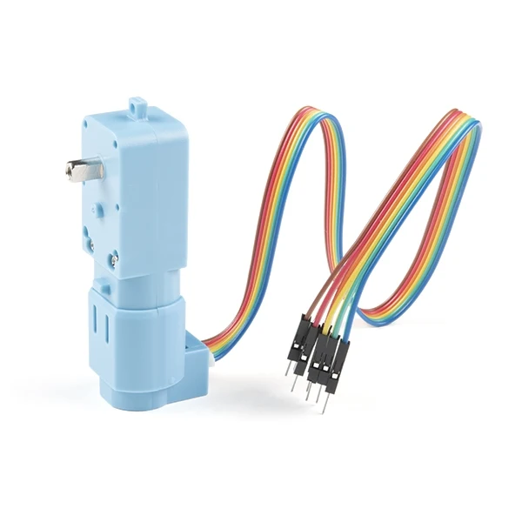
* Balancing Flywheel
  + <https://a.co/d/iU1zdFa>
  + Amazon
  + 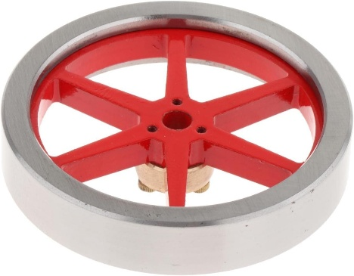
* Wheels
  + <https://a.co/d/9j6JXf9>
  + Amazon
  + 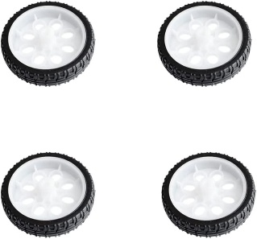
* Servo with rack
  + [Kitronik Linear Actuator Micro Servo Kit - RobotShop](https://www.robotshop.com/products/kitronik-linear-actuator-micro-servo-kit)
  + 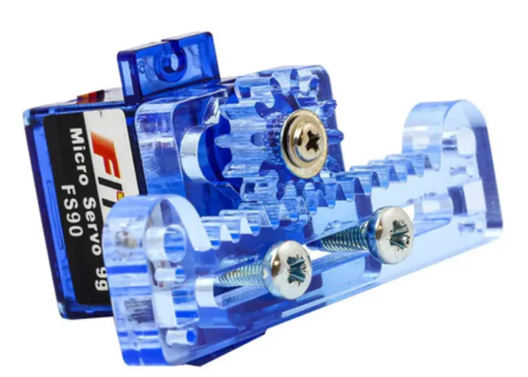
* Microcontroller
  + Arduino Nano Motor Carrier
  + <https://a.co/d/09fvVQc>
  + A blue circuit board with different colored components

    AI-generated content may be incorrect.
  + This was used by the Matlab engineering kit and the reason for choice.
  + [Self-Balancing Motorcycle Using Arduino Engineering Kit Rev 2 - MATLAB & Simulink](https://www.mathworks.com/help/matlab/supportpkg/aek-motorcycle-example.html)
  + A black motorcycle with wires and a round wheel

    AI-generated content may be incorrect.
  + Arduino Nano 33 IoT
    - <https://a.co/d/3fSDhNU>
    - A close-up of a circuit board

      AI-generated content may be incorrect.